# Uber SnowFlake

1.How many no of customers take trip from same location.a

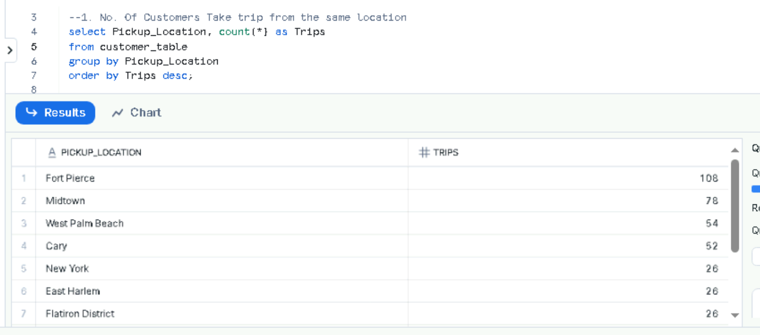

2.what is priority for each ride category from each location.

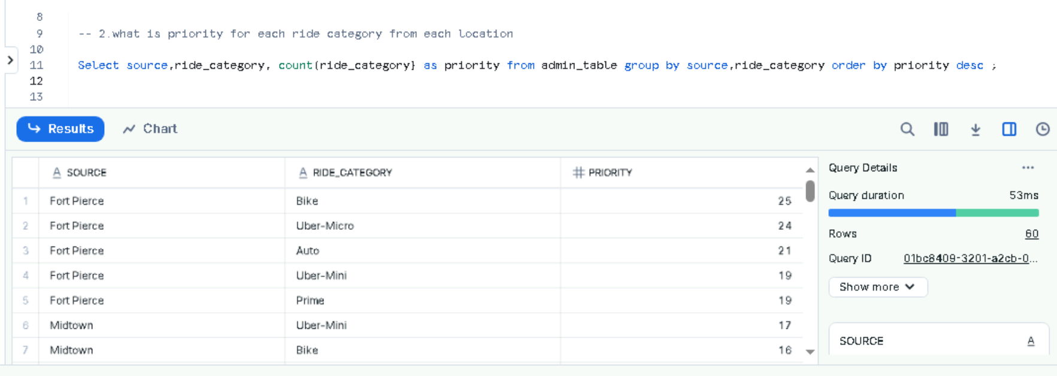

3..what are the longest locations of customer travelled.

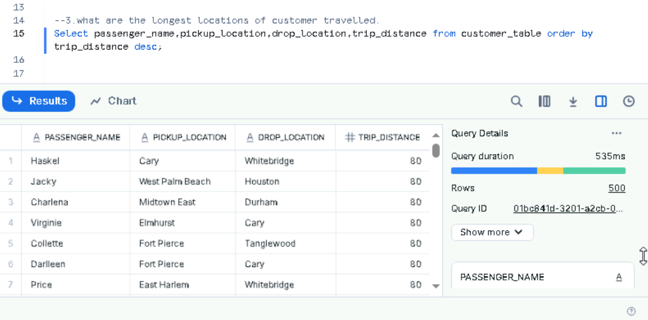

4.Drivers who completed ride with non-vaccinated customers.

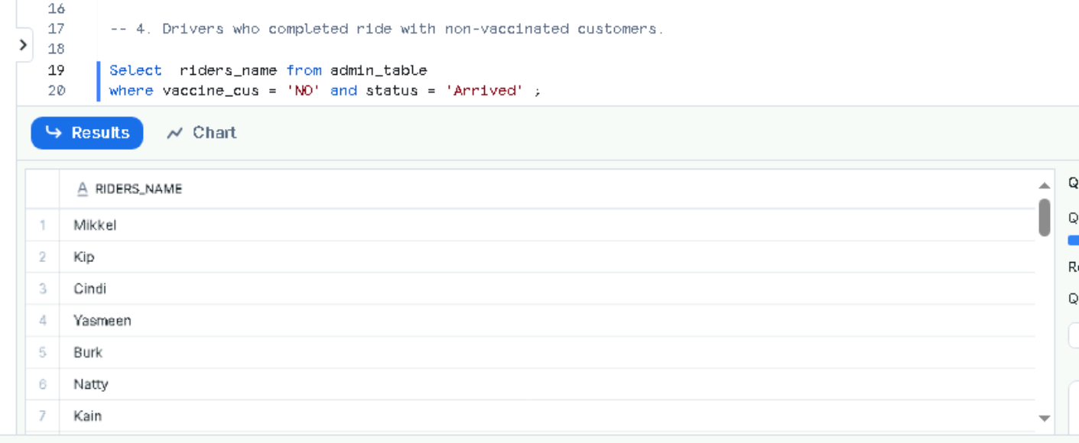

5.

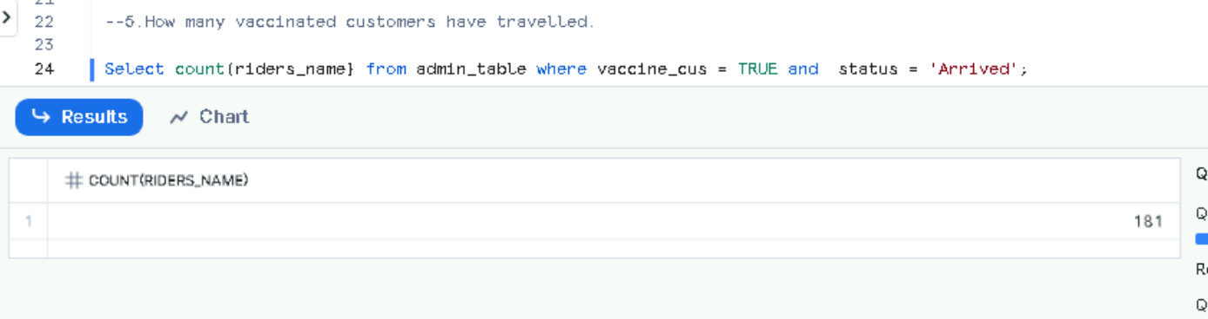

6.

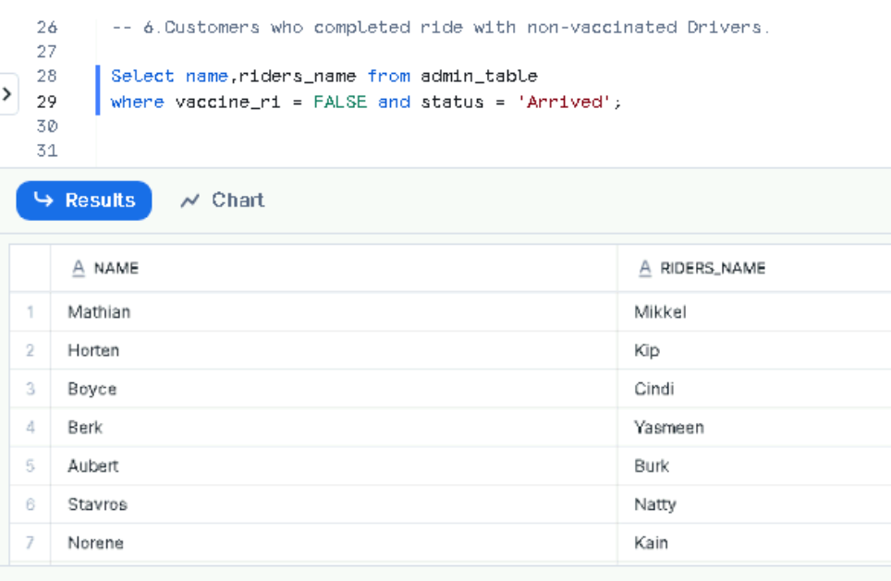

7.

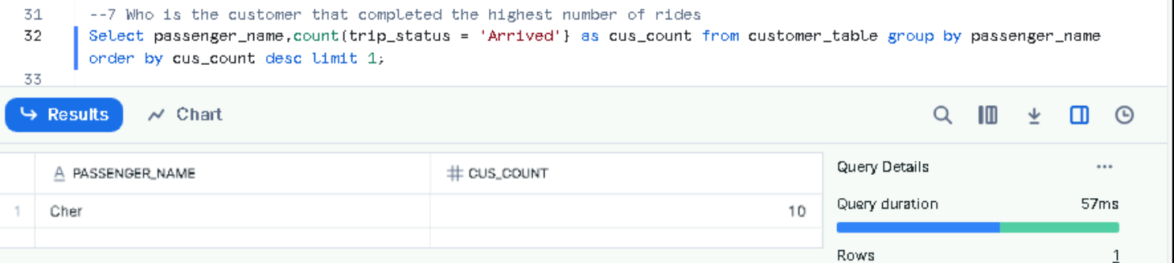

**8.**

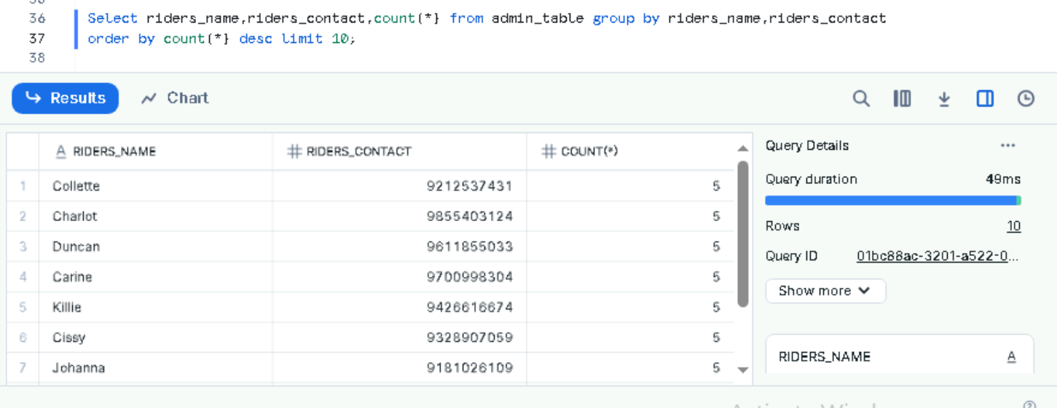

**9.**

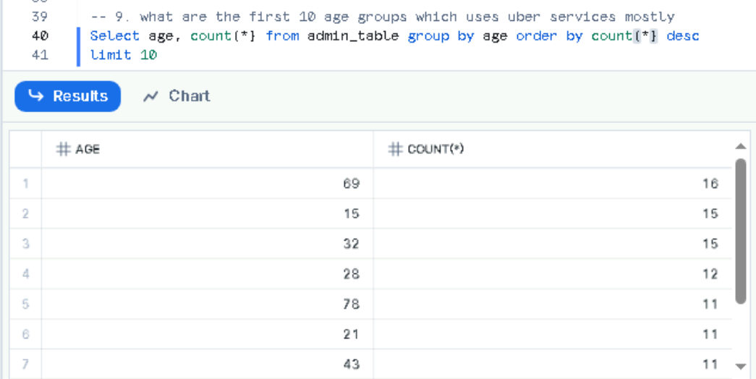

**10.**

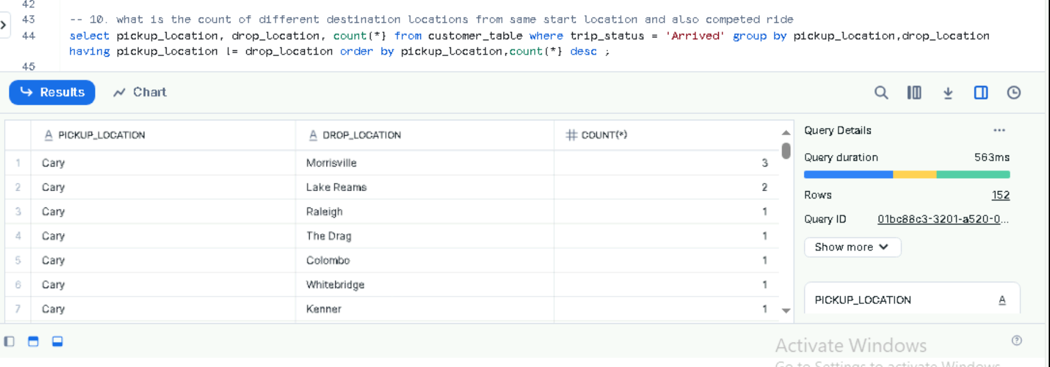

**11.**

